**JAVA Swing GUI EXAMPLES**

**JTextArea**

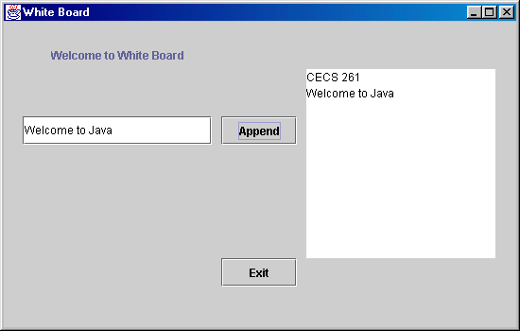

import java.io.*;  
import java.text.*;  
import javax.swing.*;  
import java.awt.*;  
import java.awt.event.*;  
  
public class WhiteBoard extends JFrame implements ActionListener  
{  
private static int WIDTH = 550;  
private static int HEIGHT = 350;  
  
private int row = 10;  
private int col = 20;  
  
//GUI components  
private JLabel headingL;  
private JTextField lineTF;  
private JTextArea whiteBoardTA;  
private JButton exitB, appendB;  
  
public WhiteBoard()  
{  
setTitle("White Board");  
Container pane = getContentPane();  
setSize(WIDTH,HEIGHT);  
  
headingL = new JLabel("Welcome to White Board");  
lineTF = new JTextField(20);  
  
whiteBoardTA = new JTextArea(row,col);  
exitB = new JButton("Exit");  
exitB.addActionListener(this);  
  
appendB = new JButton("Append");  
appendB.addActionListener(this);  
  
pane.setLayout(null);  
  
headingL.setLocation(50,20);  
lineTF.setLocation(20,100);  
whiteBoardTA.setLocation(320,50);  
appendB.setLocation(230,100);  
exitB.setLocation(230,250);  
  
headingL.setSize(200,30);  
lineTF.setSize(200,30);  
whiteBoardTA.setSize(200,200);  
appendB.setSize(80,30);  
exitB.setSize(80,30);  
  
pane.add(headingL);  
pane.add(lineTF);  
pane.add(whiteBoardTA);  
pane.add(appendB);  
pane.add(exitB);  
  
setVisible(true);  
  
} //end of the constructor  
  
public static void main(String[] args) throws IOException  
{  
WhiteBoard board = new WhiteBoard();  
}  
  
public void actionPerformed(ActionEvent e)  
{  
if(e.getActionCommand().equals("Append"))  
whiteBoardTA.append(lineTF.getText());  
else if(e.getActionCommand().equals("Exit"))  
System.exit(0);  
}  
}

**JCheckBox**

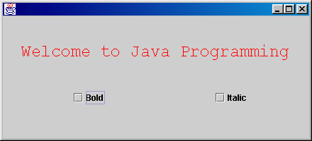

//Welcome Applet with check boxes  
  
import java.awt.*;  
import java.awt.event.*;  
import javax.swing.*;  
  
public class GrandWelcomeCheckBox extends JFrame implements  
ItemListener  
{  
private int intBold = Font.PLAIN;  
private int intItalic = Font.PLAIN;  
private JCheckBox boldCB, italicCB;  
  
GrandWelcomeCheckBox()  
{  
Container c = getContentPane();  
c.setLayout(null);  
boldCB = new JCheckBox( "Bold");  
italicCB = new JCheckBox( "Italic");  
  
boldCB.setSize(100,30);  
italicCB.setSize(100,30);  
  
boldCB.setLocation(100,100);  
italicCB.setLocation(300,100);  
  
boldCB.addItemListener(this);  
italicCB.addItemListener(this);  
  
c.add(boldCB);  
c.add(italicCB);  
}  
public static void main(String [] args)  
{GrandWelcomeCheckBox f = new GrandWelcomeCheckBox();  
f.setSize(440,200);  
f.setVisible(true);  
}  
public void paint( Graphics g)  
{  
super.paint(g);  
g.setColor(Color.red);  
g.setFont(new Font("Courier", intBold + intItalic, 24));  
g.drawString("Welcome to Java Programming",30,80);  
}  
  
public void itemStateChanged(ItemEvent e)  
{  
if(e.getSource() == boldCB)  
{   
if(e.getStateChange() == ItemEvent.SELECTED)  
intBold = Font.BOLD;  
if(e.getStateChange() == ItemEvent.DESELECTED)  
intBold = Font.PLAIN;  
}  
  
if(e.getSource() == italicCB)  
{  
if(e.getStateChange() == ItemEvent.SELECTED)  
intItalic = Font.ITALIC;  
if(e.getStateChange() == ItemEvent.DESELECTED)  
intItalic = Font.PLAIN;  
}  
  
repaint();  
}  
}

**JRadioButton**

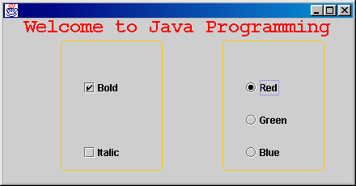

import java.awt.*;  
import java.awt.event.*;  
import javax.swing.*;  
  
public class GrandWelcomeRButton extends JFrame implements  
ItemListener  
{  
private int intBold = Font.PLAIN;  
private int intItalic = Font.PLAIN;  
private Color currentColor = Color.black;  
private JCheckBox boldCB, italicCB;  
private JRadioButton redRB, greenRB, blueRB;  
private ButtonGroup ColorSelectBGroup;  
  
GrandWelcomeRButton()  
{  
Container c = getContentPane();  
c.setLayout(null);  
boldCB = new JCheckBox("Bold");  
italicCB = new JCheckBox("Italic");  
redRB = new JRadioButton("Red");  
greenRB = new JRadioButton("Green");  
blueRB = new JRadioButton("Blue");  
  
boldCB.setSize(100,30);  
italicCB.setSize(100,30);  
redRB.setSize(100,30);  
greenRB.setSize(100,30);  
blueRB.setSize(100,30);  
  
boldCB.setLocation(100,70);  
italicCB.setLocation(100,150);  
redRB.setLocation(300,70);  
greenRB.setLocation(300,110);  
blueRB.setLocation(300,150);  
  
boldCB.addItemListener(this);  
italicCB.addItemListener(this);  
redRB.addItemListener(this);  
greenRB.addItemListener(this);  
blueRB.addItemListener(this);  
  
c.add(boldCB);  
c.add(italicCB);  
c.add(redRB);  
c.add(greenRB);  
c.add(blueRB);  
  
ColorSelectBGroup = new ButtonGroup();  
ColorSelectBGroup.add(redRB);  
ColorSelectBGroup.add(greenRB);  
ColorSelectBGroup.add(blueRB);  
}  
public static void main(String [] args)  
{GrandWelcomeRButton f = new GrandWelcomeRButton();  
f.setSize(440,230);  
f.setVisible(true);  
}  
public void paint(Graphics g)  
{  
super.paint(g);  
g.setColor(Color.orange);  
g.drawRoundRect(75,50,125,160,10,10);  
g.drawRoundRect(275,50,125,160,10,10);  
g.setColor(currentColor);  
g.setFont(new Font("Courier", intBold + intItalic, 24));  
g.drawString("Welcome to Java Programming",30,40);  
}  
  
public void itemStateChanged(ItemEvent e)  
{  
if(e.getSource() == boldCB)  
{   
if(e.getStateChange() == ItemEvent.SELECTED)  
intBold = Font.BOLD;  
if(e.getStateChange() == ItemEvent.DESELECTED)  
intBold = Font.PLAIN;  
}  
  
if(e.getSource() == italicCB)  
{  
if(e.getStateChange() == ItemEvent.SELECTED)  
intItalic = Font.ITALIC;  
if(e.getStateChange() == ItemEvent.DESELECTED)  
intItalic = Font.PLAIN;  
}   
  
if(e.getSource() == redRB)  
currentColor = Color.red;  
else if(e.getSource() == greenRB)  
currentColor = Color.green;  
else if(e.getSource() == blueRB)  
currentColor = Color.blue;  
  
repaint();  
}  
}

**JComboBox**

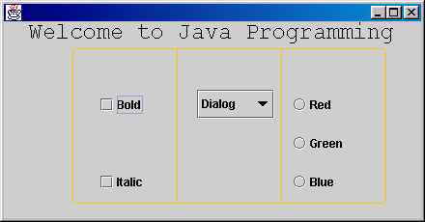

//Welcome program with check boxes, radio buttons, and combo box  
  
import java.awt.*;  
import java.awt.event.*;  
import javax.swing.*;  
  
public class GrandWelcomeFinal extends JFrame implements  
ItemListener  
{  
private int intBold = Font.PLAIN;  
private int intItalic = Font.PLAIN;  
private Color currentColor = Color.black;  
private String currentFontName ="Courier";  
private JCheckBox boldCB, italicCB;  
private JRadioButton redRB, greenRB, blueRB;  
private ButtonGroup ColorSelectBGroup;  
private JComboBox fontFaceDD;  
private String[] fontNames   
= {"Dialog","Century Gothic","Courier","Serif"};  
  
GrandWelcomeFinal()  
{  
Container c = getContentPane();  
c.setLayout(null);  
boldCB = new JCheckBox("Bold");  
italicCB = new JCheckBox("Italic");  
redRB = new JRadioButton("Red");  
greenRB = new JRadioButton("Green");  
blueRB = new JRadioButton("Blue");  
fontFaceDD = new JComboBox(fontNames);  
fontFaceDD.setMaximumRowCount(3);  
  
boldCB.setSize(80,30);  
italicCB.setSize(80,30);  
redRB.setSize(80,30);  
greenRB.setSize(80,30);  
blueRB.setSize(80,30);  
fontFaceDD.setSize(80,30);  
  
boldCB.setLocation(100,70);  
italicCB.setLocation(100,150);  
redRB.setLocation(300,70);  
greenRB.setLocation(300,110);  
blueRB.setLocation(300,150);  
fontFaceDD.setLocation(200,70);  
  
boldCB.addItemListener(this);  
italicCB.addItemListener(this);  
redRB.addItemListener(this);  
greenRB.addItemListener(this);  
blueRB.addItemListener(this);  
fontFaceDD.addItemListener(this);  
  
c.add(boldCB);  
c.add(italicCB);  
c.add(redRB);  
c.add(greenRB);  
c.add(blueRB);  
c.add(fontFaceDD);  
ColorSelectBGroup = new ButtonGroup();  
ColorSelectBGroup.add(redRB);  
ColorSelectBGroup.add(greenRB);  
ColorSelectBGroup.add(blueRB);  
}  
public static void main(String [] args)  
{GrandWelcomeFinal f = new GrandWelcomeFinal();  
f.setSize(440,230);  
f.setVisible(true);  
}  
public void paint(Graphics g)  
{  
super.paint(g);  
g.setColor(Color.orange);  
g.drawRoundRect(75,50,324,160,10,10);  
g.drawLine(183,50,183,210);  
g.drawLine(291,50,291,210);  
  
g.setColor(currentColor);  
g.setFont(new Font(currentFontName, intBold + intItalic, 24));  
g.drawString("Welcome to Java Programming",30,40);  
}  
  
public void itemStateChanged(ItemEvent e)  
{  
if(e.getSource() == boldCB)  
{   
if(e.getStateChange() == ItemEvent.SELECTED)  
intBold = Font.BOLD;  
if(e.getStateChange() == ItemEvent.DESELECTED)  
intBold = Font.PLAIN;  
}  
  
if(e.getSource() == italicCB)  
{  
if(e.getStateChange() == ItemEvent.SELECTED)  
intItalic = Font.ITALIC;  
if(e.getStateChange() == ItemEvent.DESELECTED)  
intItalic = Font.PLAIN;  
}   
  
if(e.getSource() == redRB)  
currentColor = Color.red;  
else if(e.getSource() == greenRB)  
currentColor = Color.green;  
else if(e.getSource() == blueRB)  
currentColor = Color.blue;  
  
if(e.getSource() == fontFaceDD)  
currentFontName = fontNames[fontFaceDD.getSelectedIndex()];  
  
repaint();  
}  
}

**JList**Click [here](http://www.cecs.csulb.edu/~pnguyen/cecs277/list.zip) to down load the zip file for the example below.

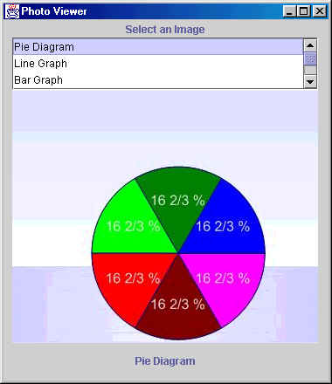

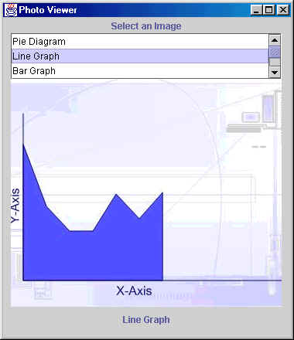

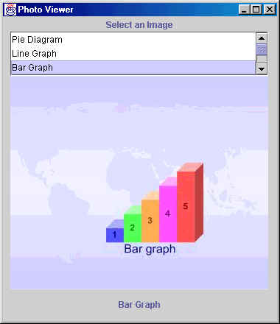

//Program to demonstrate JLIST  
  
import java.awt.*;  
import javax.swing.*;  
import javax.swing.event.*;  
  
public class JListPictureViewer extends JFrame implements  
ListSelectionListener  
{  
private String[] pictureNames = {"Pie Diagram",  
"Line Graph",  
"Bar Graph",  
"Table",  
"Normal Curve"};  
  
private ImageIcon[] pictures =  
{new ImageIcon("pieDiagram.jpg"),  
new ImageIcon("lineGraph.jpg"),  
new ImageIcon("barGraph.jpg"),  
new ImageIcon("table.jpg"),  
new ImageIcon("normalCurve.jpg")};  
  
private BorderLayout layoutBL;  
private JList pictureJList;  
private JScrollPane selectionJS;  
private JLabel promptJL;  
private JLabel displayPicJL;  
private JLabel infoJL;  
  
public JListPictureViewer()  
{  
super("Photo Viewer");  
  
Container pane = getContentPane();  
pane.setLayout(null);  
  
promptJL = new JLabel("Select an Image",  
SwingConstants.CENTER);  
promptJL.setSize(350,20);  
promptJL.setLocation(10,0);  
pane.add(promptJL);  
  
pictureJList = new JList(pictureNames);  
pictureJList.setVisibleRowCount(3);  
pictureJList.setSelectionMode  
(ListSelectionModel.SINGLE_SELECTION);  
pictureJList.addListSelectionListener(this);  
  
selectionJS = new JScrollPane(pictureJList);  
selectionJS.setSize(350,60);  
selectionJS.setLocation(10,20);  
pane.add(selectionJS);  
  
displayPicJL = new JLabel(pictures[4]);  
displayPicJL.setSize(350,350);  
displayPicJL.setLocation(10,50);  
  
pane.add(displayPicJL);  
  
infoJL = new JLabel(pictureNames[4],  
SwingConstants.CENTER);  
infoJL.setSize(350,20);  
infoJL.setLocation(10,380);  
pane.add(infoJL);  
  
setSize (380, 440);  
setVisible(true);  
// setDefaultCloseOperation(EXIT_ON_CLOSE);  
}  
  
public static void main(String args[])  
{  
JListPictureViewer picViewer = new JListPictureViewer();  
}  
  
public void valueChanged(ListSelectionEvent e)  
{  
displayPicJL.setIcon(  
pictures[pictureJList.getSelectedIndex()]);  
infoJL.setText(  
pictureNames[pictureJList.getSelectedIndex()]);  
repaint();  
}  
}